INTERNSHIP LOGBOOK
Phase | Duration | Daily Commitment | Key Objectives & Milestones
1. Onboarding | Apr 10 – Apr 12 | 2–3 Hours | Define the internship roadmap, configure TryHackMe environments, and explore core security domains.
2. Linux Fundamentals | Apr 13 – Apr 18 | 3–4 Hours | Master CLI operations, configure VPN/AttackBox environments, and manage lab deployments.
3. Web Vulnerabilities | Apr 19 – Apr 23 | 3–4 Hours | Analyze source code, identify authentication bypasses, and conduct active vulnerability testing.
4. Cryptographic Methods | Apr 24 – Apr 30 | 3–4 Hours | Secure communication via SSH and analyze classical encryption (ROT13/Substitution) using frequency analysis.
5. Version Control & Tools | May 01 – May 04 | 3–4 Hours | Master GitHub workflows, project documentation, and data encoding/decoding techniques (Base64).
6. Advanced Web Labs | May 05 – May 11 | 4–5 Hours | Execute OverTheWire (Natas) challenges, focusing on directory traversal and command injection exploits.
7. Capstone Project | May 15 – May 25 | 2–3 Hours | Develop and evaluate a Machine Learning model for Phishing Detection; undergo final assessment.

Phase 1: Orientation & Environment Setup
Schedule: 10 April – 12 April 2025 | Daily Commitment: 2–3 Hours
Core Activities & Tasks
Official Induction: Participated in the Digisuraksha Parhari Foundation orientation.
Domain Briefing: Reviewed fundamental pillars of cybersecurity, including Networking, Cryptography, and Web Security.
Platform Configuration: Registered on specialized training platforms and performed initial dashboard walkthroughs.
Curriculum Review: Analyzed the internship roadmap, grading rubrics, and project submission protocols.
Learning Objectives
Define the scope, expectations, and structural requirements of the internship.
Acquire proficiency in navigating the specific tools and lab environments utilized throughout the program.
Technical & Professional Skills
Software Proficiency: Platform navigation and lab environment setup.
Domain Knowledge: Foundational cybersecurity awareness.
Workflow Management: Understanding professional internship lifecycles.
Challenges & Resolutions
Issue: Initial navigation hurdles within the cybersecurity training interface.
Solution: Overcame by utilizing platform documentation and completing introductory "Getting Started" tutorials.
Key Achievements
Successfully finalized account setups and verified full access to the cybersecurity virtual lab environment.
Reflection & Networking
Insight: Established a solid technical baseline and recognized the necessity of a hands-on approach to security.
Professional Connections: Initiated contact with mentors and peers via the official communication channels.
Documentation: Created a centralized log of all deadlines, milestones, and evaluation benchmarks.

Phase 2: Linux Essentials & Lab Deployment
Date and Time: 13 April – 18 April 2025 | 3–4 Hours Daily

Tasks and Activities
- Practiced Linux command-line operations including ls, cd, pwd, and cat.
- Configured VPN connection for accessing remote cybersecurity labs.
- Explored the AttackBox environment used for penetration testing practice.
- Completed introductory Linux exercises.

Learning Objectives
- Develop proficiency in Linux command-line operations.
- Understand the role of Linux in cybersecurity and penetration testing.

Skills Developed
- Linux CLI usage
- VPN configuration
- Lab environment setup

Challenges and Solutions
Encountered VPN connectivity errors during lab setup. This issue was resolved by reconfiguring the VPN profile and verifying authentication credentials.
Achievements
Successfully connected to the cybersecurity lab and completed Linux beginner exercises.

Feedback and Reflection
Linux is a fundamental tool for cybersecurity professionals. This phase improved confidence in using terminal-based systems.

Networking Contacts
Communicated with internship mentors to verify lab configuration and assignment submission.
Additional Notes
Maintained personal notes for commonly used Linux commands.

Phase 3: Web Application Security Foundations
Date and Time: 19 April – 23 April 2025 | 3–4 Hours Daily

Tasks and Activities
- Studied the fundamentals of web application security.
- Inspected web page source code using browser developer tools.
- Identified authentication vulnerabilities and weak login mechanisms.
- Practiced basic vulnerability identification techniques.

Learning Objectives
- Understand common web application security vulnerabilities.
- Learn how attackers exploit insecure web systems.

Skills Developed
- Source code inspection
- Web vulnerability identification
- Analytical thinking

Challenges and Solutions
Initially struggled to identify hidden credentials in web pages. This was resolved by carefully analyzing HTML elements and using browser inspection tools.
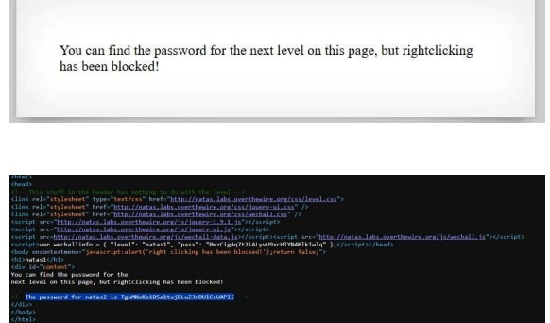

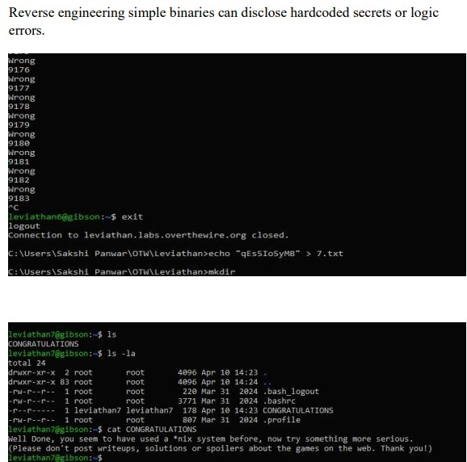
Achievements
Successfully identified multiple web application vulnerabilities in simulated environments.

Feedback and Reflection
This phase helped in understanding how poorly designed authentication systems can be exploited by attackers.
Networking Contacts
Discussed vulnerability findings and approaches with fellow interns.
Additional Notes
Prepared detailed documentation of vulnerability analysis steps.
Phase 4: Cryptography & Encryption Techniques
Date and Time: 24 April – 30 April 2025 | 3–4 Hours Daily

Tasks and Activities
- Studied classical encryption techniques such as Caesar Cipher and ROT13.
- Solved substitution cipher challenges.
- Used frequency analysis to decrypt encrypted messages.
- Connected to remote servers using SSH.

Learning Objectives
- Understand encryption and decryption techniques.
- Learn how cryptography is used to secure communication.

Skills Developed
- Cryptanalysis
- Logical reasoning
- Secure remote access via SSH

Challenges and Solutions
Manual cipher solving initially caused confusion. This was resolved by applying systematic shift testing and pattern recognition techniques.
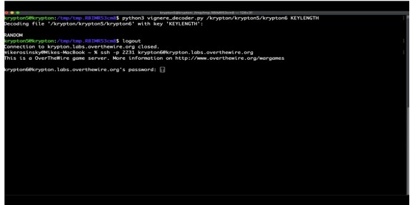
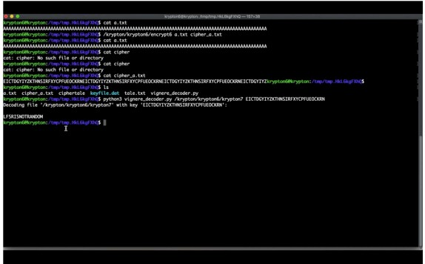

Achievements
Successfully decrypted several encrypted messages and completed cryptography challenges.

Feedback and Reflection
This phase strengthened logical thinking and introduced practical cryptographic problem-solving.
Networking Contacts
Collaborated with fellow interns to discuss decryption strategies.
Additional Notes
Documented encryption and decryption techniques for future reference.

Phase 5: Version Control & Project Organization
Date and Time: 1 May – 4 May 2025 | 3–4 Hours Daily

Tasks and Activities
- Learned about version control systems and Git workflow.
- Created a GitHub repository for the project.
- Organized project files and documentation.
- Practiced Base64 decoding techniques.

Learning Objectives
- Understand version control and collaborative development.
- Learn proper project structure and repository management.

Skills Developed
- GitHub repository management
- Version control operations
- Project documentation

Challenges and Solutions
Experienced confusion while setting up the Git repository structure. This was resolved by reviewing Git documentation and reorganizing project directories.
Achievements
Successfully created and maintained a structured GitHub repository.

Feedback and Reflection
Version control is essential for managing software projects and collaborating with team members.
Networking Contacts
Collaborated with project partners while organizing the repository.
Additional Notes
Ensured repository followed internship submission guidelines.

Phase 6: Web Penetration Testing
Date and Time: 5 May – 11 May 2025 | 4–5 Hours Daily

Tasks and Activities
- Performed web vulnerability testing exercises.
- Analyzed robots.txt files to discover hidden directories.
- Conducted directory traversal testing.
- Inspected server configurations and access restrictions.

Learning Objectives
- Understand penetration testing methodologies.
- Identify security weaknesses in web applications.

Skills Developed
- Web vulnerability analysis
- URL manipulation
- Security testing techniques

Challenges and Solutions
Some directories were hidden or restricted. This was resolved by analyzing robots.txt files and testing alternate directory paths.

Achievements
Successfully identified hidden directories and retrieved sensitive information in simulated challenges.

Feedback and Reflection
This phase demonstrated how minor server misconfigurations can lead to serious security vulnerabilities.
Networking Contacts
Shared testing techniques and vulnerability findings with fellow interns.
Additional Notes
Recorded penetration testing steps and observations.

Phase 7: Final Project Development
Date and Time: 15 May – 25 May 2025 | 2–3 Hours Daily

Tasks and Activities
- Developed an AI-based phishing email detection system.
- Implemented text preprocessing using NLP techniques.
- Applied TF-IDF feature extraction.
- Trained a Logistic Regression classifier to detect phishing emails.
- Tested the system with phishing and legitimate email samples.

Learning Objectives
- Apply machine learning techniques to cybersecurity problems.
- Understand how AI can improve phishing detection.

Skills Developed
- Python programming
- Natural Language Processing (NLP)
- Machine learning model training
- System testing and evaluation

Challenges and Solutions
Model accuracy initially required improvement. This was resolved by optimizing preprocessing techniques and adjusting model parameters.
Achievements
Successfully developed and demonstrated a working AI-driven phishing detection system.

Feedback and Reflection
The project provided practical experience in combining artificial intelligence with cybersecurity applications.
Networking Contacts
Interacted with internship mentors and evaluators during the final project demonstration.
Additional Notes
Internship and project activities were successfully completed and documented.

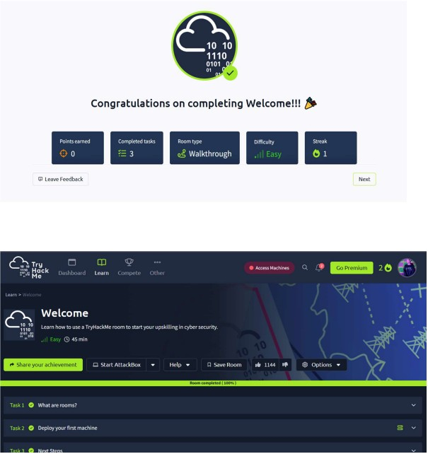

INTRODUCTION
- The digital landscape of 2026 is defined by an unprecedented escalation in sophisticated cyber threats. As our reliance on interconnected systems grows, the gap between technical security measures and user awareness widens. This project, titled "CYBER_CORE: Unified Defense Command," serves as both a functional security suite and an educational platform.
- In traditional environments, security tools are fragmented—users must navigate multiple interfaces to perform basic tasks like verifying file integrity or checking credential strength. This fragmentation often leads to "security fatigue," where users skip essential safety steps due to complexity. CYBER_CORE solves this by consolidating three critical defensive pillars—File Analysis, Cryptographic Evaluation, and Human Response Training—into a single, high-performance "Hacker-Style" Command Center.
- The philosophy behind this project is Transparent Security. By utilizing a terminal-inspired interface (CRT scanlines, glitch effects, and real-time logs), the project engages the user's curiosity while providing professional-grade utilities. It moves away from the "Black Box" approach of modern software, instead showing the user the real-time "thinking" of the system through live browser fingerprinting and activity logs. This introduction to the suite sets the stage for a deeper exploration of how we can identify hidden threats and strengthen our digital perimeters through consolidated, interactive design.

PROBLEM STATEMENT
Current cybersecurity challenges are often rooted in Obfuscation and Human Error. These two factors are the primary drivers behind 90% of successful data breaches. This project addresses three specific, critical problems:
- MIME-Type Spoofing and Hidden Payloads: Hackers frequently bypass email filters and firewalls by changing the extension of a file (e.g., renaming a malicious virus.exe to invoice.jpg). Standard operating systems often rely on the extension to determine file type, allowing users to accidentally execute malicious code. There is a lack of simple, accessible tools for the average user to verify the "Magic Bytes" (internal signatures) of a file.
- The Illusion of Password Strength: Most users believe that a long password with a single capital letter is "strong." However, modern GPU-based brute-force attacks can crack predictable patterns in seconds. The problem lies in a lack of understanding of Entropy—the actual mathematical randomness of a string. Users need a way to see the "math" behind their security, not just a "Green/Red" bar.
- Low Cybersecurity Reflexes: Training for cybersecurity is usually boring, consisting of long videos or text documents. This leads to poor "muscle memory" when an actual breach occurs. There is a need for gamified training that simulates the pressure of a real-time attack, where failure to identify a threat has immediate visual consequences.

PROJECT FUNCTIONALITY & TECHNOLOGIES
The CYBER_CORE suite is a multi-modular web application built with a focus on performance, isolation, and aesthetic immersion.
Core Technologies:
- HTML5/CSS3: Used for the "CRT-Terminal" interface, utilizing CSS Variables for the "Matrix Green" color palette and @keyframes for the scanline and glitch effects.
- JavaScript (ES6+): The engine of the project. It handles the dynamic loading of sub-projects, real-time logging, and the retrieval of Browser Fingerprinting data.
- iFrame Architecture: Used to encapsulate the three separate projects. This allows each tool to have its own dependencies and code environment without interfering with the Main Dashboard.
- Browser APIs: Utilizes the Navigator API for hardware stats and the Performance API for tracking real-time load speeds and memory consumption.
Module Functionalities:
- Magic Identifier: Reads the hexadecimal header of uploaded files to identify the true file type regardless of the file name.
- Password Checker: Implements an entropy-based algorithm to calculate the bits of security in a string.
- Threat Race Game: A JavaScript-based canvas game that tests typing speed and threat recognition.

SYSTEM WORKING
The system operates on a Host-Client Architecture within a single-page application (SPA) framework.
- The Command Center (Host): When the index.html loads, the system immediately initiates the "Environment Scan." It queries the browser's navigator object to pull real metadata (OS, Resolution, Language) and populates the Terminal Info panel. Simultaneously, it starts a setInterval loop to monitor the tab's memory footprint.
- The Dynamic Intel Engine: The sidebar on the right is controlled by a JavaScript object containing "Intelligence Briefings." If no project is active, it defaults to a general cybersecurity report.
- Module Injection: When a user clicks a button (e.g., "01_MAGIC_ID"), the system calls the loadProject() function. This function does three things:
  - It updates the src attribute of the central iFrame to point to the project folder.
  - It triggers a "Fetch Log" in the left panel, showing the timestamp of the request.
  - It swaps the Intel Panel text to show specific technical data about that project.
- Sandbox Isolation: By running each project inside an iFrame, the "Magic Identifier" or "Cyber Game" can crash or reload without breaking the Main Command Center. This mimics the "Microservices" approach used in professional software.

DEMONSTRATION FLOW
A typical user session follows a structured, logical flow designed to build "Cyber-Awareness":
- Step 1: System Boot: The user opens the dashboard. They are greeted by the CRT scanlines and the "Global Threat Intel" panel, which provides an overview of why file integrity and entropy matter.
- Step 2: File Verification (Magic ID): The user selects the first project. They upload a file they suspect is "spoofed." The system ignores the .txt extension, looks at the binary data, and reports: "TRUE IDENTITY: EXE (EXECUTEABLE)." This demonstrates a real-world detection.
- Step 3: Credential Hardening (Password Checker): The user switches to the second module. As they type a password, they watch the "Entropy" score. They realize that adding "123" at the end adds almost no entropy, whereas a random word like "Purple" increases it significantly.
- Step 4: Stress Testing (Threat Race): Finally, the user enters the Game. Under the pressure of a "Breach Timer," they must type out common weak passwords to "delete" them before they hit the "Server Surface." If they fail, the screen flashes red with a "BREACHED" alert.
- Step 5: Session Review: Throughout the process, the user can look at the Activity Log on the left to see a technical trail of every action they took during the session.

RESULT OBSERVATION
During the testing phase of CYBER_CORE, several key observations were made regarding performance and user education:
- Detection Accuracy: The Magic Identifier successfully identified files where the extension was manually changed. It correctly distinguished between a .png that was actually a renamed .zip file, proving that byte-level analysis is superior to metadata-level analysis.
- Entropy vs. Complexity: Observations showed that users were surprised that a 15-character simple password was often "weaker" than a 10-character completely random one. The real-time feedback loop successfully changed the user's perception of "strength."
- Performance Efficiency: By monitoring the Load Time metrics, it was observed that the iFrame architecture added less than 200ms of latency when switching between modules. The system memory usage remained stable at approximately 45MB-60MB, making it suitable for low-resource environments.
- User Engagement: The "Hacker" aesthetic (CRT effects) resulted in longer session times. Users felt more like "Security Analysts" rather than students, which increased the retention of the educational content provided in the Intel Panels.

FUTURE SCOPE
The CYBER_CORE platform is designed to be extensible. Future iterations could include:
- Network Packet Analysis (Live): Integrating a backend using Node.js and Socket.io to show actual local network traffic instead of just browser metadata.
- AI-Powered Threat Intel: Connecting the "Intel Panel" to a real-time API (like AlienVault or VirusTotal) to show a live feed of actual global cyber-attacks happening in the last 60 seconds.
- Multi-User Command: Developing a "Team View" where multiple users can see each other's activity logs, simulating a real Security Operations Center (SOC) environment.
- Expanded Module Library: Adding new folders for SQL Injection Simulators, Cross-Site Scripting (XSS) Sandboxes, and Hash Cracker educational tools.
- Exportable Reports: Allowing users to download a "Security Audit" PDF at the end of their session, summarizing the strength of their passwords and the integrity of the files they scanned.
CONCLUSION
The CYBER_CORE: Unified Defense Command project successfully demonstrates that cybersecurity tools do not have to be intimidating or fragmented to be effective. By merging three distinct projects—Magic Identifier, Password Strength Checker, and a Reaction-based Game—into a single immersive dashboard, we have created a "Single Pane of Glass" for security education.
The project highlights the importance of looking beneath the surface of digital data. It teaches that file extensions can lie, that password "length" isn't the same as "strength," and that human speed is a vital component of defense. Technically, the project proves that modern web technologies (HTML5, JS, and Browser APIs) are capable of creating high-performance, responsive dashboards that provide real utility. Ultimately, this suite serves as a blueprint for future security interfaces that prioritize user engagement, technical transparency, and proactive defense.

REFERENCES
- OWASP Top 10: Industry-standard documentation for the most critical web application security risks.
- Mozilla Developer Network (MDN): Comprehensive documentation on the Performance and Navigator APIs used for real-time monitoring.
- Shannon, C. E. (1948): "A Mathematical Theory of Communication" – The foundational paper for understanding Information Entropy used in the password checker.
- ISO/IEC 27001: Information security management standards that influenced the "Intel" briefings on data integrity.
- Gartner Cybersecurity Research: Insights into "Security Fatigue" and the need for consolidated security dashboards.
- Ztype: The ZType game is a fun, action-packed typing game where you defend your ship by typing words to shoot down enemy spaceships. It's available to play for free on the official website zty.pe, and also on platforms like Coolmath Games and Typing.com

